

THE CHELM PROJECT

How making people LAUGH about Israel,
instead of feeling SAD, ANGUISHED, DISHEARTENED, WORRIED, DISENCHANTED, UNCOMFORTABLE, ASHAMED OR ANGRY can transform Israel’s image.

DANIELLA ASHKENAZY

SLIDE #1:

WE ALL KNOW ISRAEL’S IMAGE IS TERRIBLE

The mood is getting uglier and more frightening by the day

Nothing helps
- not Alan Dershowitz’s brains
- not Bar Rafaeli’s body

WHAT ISRAEL NEEDS IS…

A ‘LAUGHTER BRIGADE’!

MEET CHELM-ON-THE-MED©
- A BREAKTHROUGH CONCEPT IN PUBLIC DIPLOMACY



SLIDE #2:
WHAT IS CHELM-ON-THE-MED©?

CHELM-ON-THE-MED© is an independent multimedia news platform established by Daniella Ashkenazy – a seasoned bilingual Israeli freelance journalist.



Chelm-on-the-Med’s Winking Flag Logo

CHELM-ON-THE-MED© collects and publishes in English incredible snippets of zany news about Israel gleaned from the Hebrew press that never make The Washington Post.

Not even The Jerusalem Post…

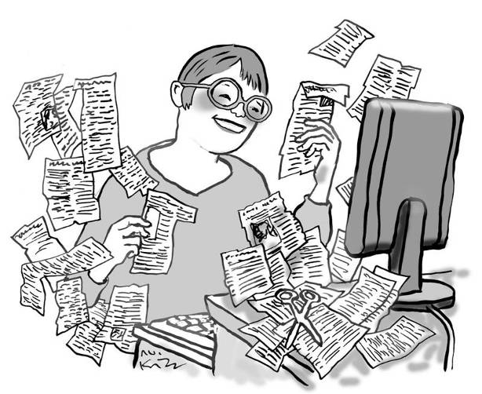

READ Chelm-on-the-Med© Online at: www.chelm-on-the.med.com

VIEW the Animated News Demo for Television on YouTube: http://www.youtube.com/watch?v=MoUmGgbD6uk
SLIDE #3: WHY ‘CHELM’?

CHELM is an actual Jewish town in Poland that for generations served as the butt of Yiddish folk humor, tagged with the role of being ‘a paradise filled with life-embracing fools’...

 |  |  | 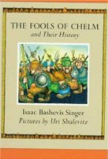 | 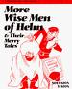

Daniella Ashkenazy: “What passes for ‘normalcy’ in the Jewish state all-too-often sounds like a modern-day Chelm. The difference is, I’m not making these stories up. I’m not even exaggerating…”

SLIDE #4: WHY CHELM (CONT.)

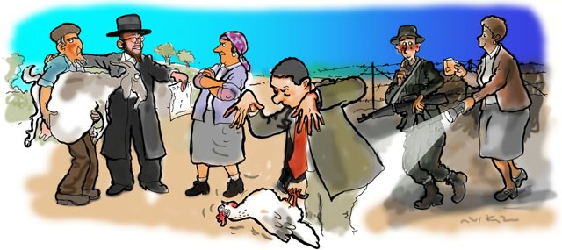 | 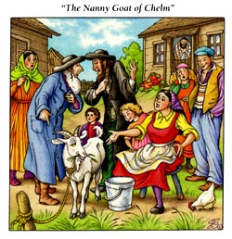

☼ …An Israeli soldier whose ultimate Jewish mother snuck into boot camp every night to accompany her son on guard duty because he was afraid of the dark

☼ …A senior Israeli minister who chose to enchant the press by mesmerizing a chicken, leaving the bird on its back looking like an oversized zapped cockroach

☼ …A court ruling on a divorce settlement requiring the divorcee to pay his former spouse one pregnant goat a year for the next 35 years – raising serious questions over ‘who got whose goat’.

SLIDE #5: CHELM THEMES:

MAN-BITE-DOG STORIES & BACK-PAGE NEWS

♣ Silly ministers & parliamentarians
♣ Quirky mayors & eccentric rabbis
♣ Weird court cases
♣ Two-bit crooks & odd capers
♣ Kafka-like ordinances
♣ Incredible bureaucratic tangles
♣ Dumb or kind-hearted cops
♣ Unforgettable ‘he & she’ sagas
♣ IDF oddities and idiosyncrasies
♣ Only-in-Israel quandaries
♣ Only-in-Israel solutions

♣ Countless run-of-the-mill Israelis whose harebrained schemes or bizarre behavior land them in the daily papers.



"When a dog bites a man, that is not news, because it happens so often. But if a man bites a dog, that is news." John B. Bogart (1848–1921), editor New York Sun

Daniella Ashkenazy: "Israel is a real place. It has all the crazy elements that humanity as a whole is 'blessed' with. Repeated encounters with 'the real Israel' – is enriching and reinforcing and even empowers the audience with images that balance preconceptions of reality. Laughter is liberating!"
SLIDE #6: OK, BUT IS IT 'NEWS"??

Daniella Ashkenazy: "CHELM-ON-THE-MED did not invent the wheel. "Soft news" is an established and popular news category.

Odd News in Leading Media: Several Examples
♦ Reuters’ “Oddly Enough”
♦ ABC’s “The Wolf Files”
♦ USA Today’s “Slightly Off Center”
♦ BBC’s “Also in the news…”
♦ Sky News’s “Strange News”

Established Freelance Columns: A Popularity Barometer

Chuck Shepherd’s  News of the Weird  Universal Press Syndicate | Syndicated in 250 papers worldwide  Best-seller anthologies
Randy Cassingham’s  This is True (www.thisistrue.com) | 156,000 subscribers in over 200 countries)

SLIDE #7: OK, BUT IS IT 'NEWS"?? (CONT.)

♣ CNN REVEALS: CNN website tracking statistics found that the ten most popular stories in 2004 – based on usage of the channel's “E-mail This” story tool – were all “weird, macabre, heartwarming, amusing and otherwise offbeat news items” – not hard news, although 2004 was a presidential election year.

♣ YOU-TUBE REVEALS: A classic comedy routine "Achmad the Dead Terrorist" by ventriloquist Jeff Dunham attracts 117 million hits; LATMA's spoof of the Gaza Flotila ship Marmara "We Con the World" got over two million hits.
SLIDE 8: WEAKNESSES
OF CONFLICT-DRIVEN* PUBLIC DIPLOMACY (HASBARA)

● Traditional 'Serious' Argumentation – Governmental and NGOs

► Too cerebral: Attracts only serious students of the conflict

► Limited outreach: Mostly ‘preaches to the choir’

► Narrow/Dehumanizing: Re-enforces a ‘victims or victimizer’ narrative

► Ineffective: Cannot ‘match’ horrific images Palestinians present

► ‘Rules’ are Biased: Attempts to provide context or show Israelis suffering cannot ‘win’ when media engages in body counts

► ‘Misbrands’ Israel: ISRAEL = Bloodshed and Violence

● Use of Humor by Others – Government and NGOs
► Focuses on The Conflict only.
► At times too In-Your-Face for mass appeal
► Sporadic - ad-hoc and reactive

See Appendix A for examples

* Focusing on the Israel-Arab Conflict – by both the Government and NGOs
SLIDE 9: WEAKNESSES
OF CURRENT "BEYOND-THE-CONFLICT"* PUBLIC DIPLOMACY (HASBARA)

● Israel 21c (www.israel21c.org):
► Low Credibility: Only ‘Positive’ News ↔ Managed News

► Ineffectual: Images are too mild to leave a lasting effect

► ‘Conservative’: Its mandate excludes humor/satire

► Short-sighted: Editorial policy ignores there are funny aspects of conflict.

● Israelity (http://israelity.com/):
► Myopic/Introspective Lens: Personal Sagas ↔ Narrowly ‘Filtered’ Focus

* Focusing on scientific and technological achievements, positive social trends and Do-Gooders and personal blogs by run-of-the-mill Israelis

SLIDE 9: SOLUTIONS TO WEAKNESSES
IN CURRENT PUBLIC DIPLOMACY

CHELM-ON-THE-MED© is a Society-Generated Mosaic

► Unfiltered & Unbiased

► Un-manipulated & ‘Unmanageable’

► Quirky & Laid-back

► Indelible Images that leave a Lasting Impression

► Reaches New Demographics

Stories of this nature have hidden value for Israeli advocacy.

Exposure to "the real Israel" can re-brand Israel as warm, human and inviting, funny and full of surprises.

SLIDE 10: THE CHELM-ON-THE-MED MOSAIC
OPERATING PRINCIPLES
(ALL PLATFORMS)

THE PUBLIC DIPLOMACY ‘DIVIDEND’

CHELM-ON-THE-MED© ONLINE is a bona fide news site.

CHELM-ON-THE-MED© 's utility for Israel advocacy is a derivative.

CHELM-ON-THE-MED©'s FIVE OPERATING PRINCIPLES:

1, Content: Raw material is news-rooted/news-gathered from reputable Israeli (Hebrew) print media

2. Editorial autonomy and objectivity: All sectors of society are ‘fair game’ (Jew-Arab, religious-secular, old-timers-new immigrants, straight-gay, etc.)

3. No subject is taboo: There are even hilarious aspects of The Conflict.

4. The Perspective: News items are based on ‘laughing with’ – not ‘laughing at’ Israel.

5. Universality: The only reservation or ‘filter’ - Humor only works when the incongruity of the situation can be recognized by the listener/viewer.

More than Infotainment at Its Best: French philosopher and critic Roland Barthes who pioneered social theory argued that popular cultural material is a social barometer, significant beyond its face value. French philosopher, sociologist and anthropologist Pierre Bourdieu who pioneered the concept of "cultural fields" and "social capital" held one can read the trivia of everyday life as full of meaning about a society. Chelm-like stories paint a genuine mosaic of the 'fabric' of Israeli society.

A New Genre: Televised CHELM segments are ‘animated news' – not editorial cartooning. The message is non-judgmental. Animated news segments are a groundbreaking concept in journalism.

SLIDE #11: HOW CHELM DIFFERS
FROM OTHER USES OF HUMOR TO RE-BRAND ISRAEL

- FREQUENCY & TIMING: Ad hoc and/or Reactive - Proactive and Ongoing

- USE OF WIT: Not satire or editorial cartooning - Situational non-confrontational ('devious') humor-based

- GOAL: No business/political objectives - News & Entertainment-directed

- SUITABILITY: Not controversially-crude/racy - For Virtually All Audiences

- SHELF-LIFE: Not narrowly topical in response to breaking news – Always Fresh and Refreshing

- SCOPE: Not narrowly focused on conflict issues or The Conflict – Broad-scope

- SOURCE: Scripted - Society-generated

- FREQUENCY: Not ad-hoc – Ongoing.

Go to Appendix A at the back for Use of Humor by Others

SLIDE #12: "ISRAEL'S IMAGE ISN'T A LAUGHING MATTER!" OH YEAH? (CONT.)

Daniella Ashkenazy: "Israel indeed faces an existential danger from divestors who demonize Israel and question its very right to exist. The situation is grave and worrisome, but humor is a powerful tool. For Israel advocacy activists not to apply humor as an effective "unconventional weapon" in the Image War would be a folly."

► People EVERYWHERE do nutty and nervy things that land them in the news. MILLIONS of Odd News Junkies read about them.

► Piquant news 'UNITES' Israelis with THE REST OF HUMANITY…and then some.

COMPARE piquant news items published by Odd News sites, and odd news items culled from the Hebrew press by The Chelm Project. Go to Appendix B.

SLIDE #13: "ISRAEL'S IMAGE ISN'T A LAUGHING MATTER!" OH YEAH? (CONT.)

YET, IRONICALLY

Israel is MISSING from Odd News sites!

WHY?

■ Israel is viewed through a political or religious lens.

■ News coverage about Israel is conflict-driven.

■ Most zany ‘soft’ news is only published in Hebrew.

SLIDE #14: "ISRAEL'S IMAGE ISN'T A LAUGHING MATTER!" OH YEAH? (CONT.)

TWO CLASSIC EXAMPLES of Israeli odd news never reported abroad …that occurred in Israel during the 2000-2005 terror war – underscoring; Israelis do nutty things even in the worst of times!

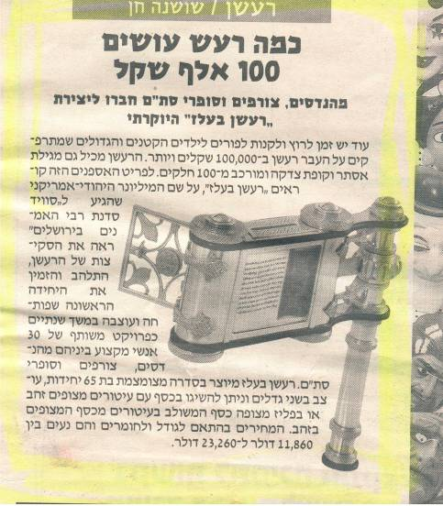

Meet the priciest Purim grogger ($23,260) since the 5th Century BCE. The designer noisemaker not only includes a handwritten scroll with the entire Book of Ester; there’s also a tzadaka (charity) box – offering the lucky owners an ingenious way to recap their investment.

SLIDE #15: CLASSIC EXAMPLES OF NEWS THAT NEVER MADE THE WASHINGTON POST. NOT EVEN THE JERUSALEM POST

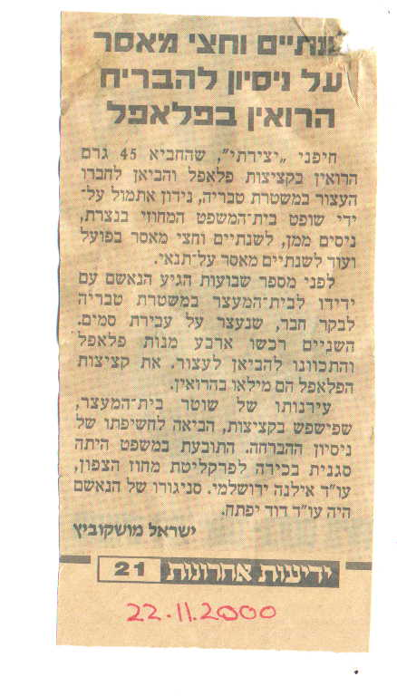

A visitor at the Tiberius lockup who brought his closest buddy four piping hot falafels, filled not only with finely diced salad and tachina spread; the treat was also laced with 45 grams of heroin stashed inside the balls – which left the bearer of gifts in a genuine pickle after guards examined his balls.

SLIDE #16: WHY HUMOR 'WORKS'

HUMOR…

● Counters focus group findings: Israel is ‘dangerous’ ‘fanatic’ ‘tight-assed’

● Can change perceptions in two problematic areas: the IDF and religion

● Replaces ‘Apartheid’ state’ or ‘pariah state’ status, with ‘zany state’ image

● Reaches a huge new demographic – consumers of ‘News of the Weird’

● Indirect/unconscious positive impact, because…

LAUGHTER

► is universal/spontaneous/ infectious/’addictive’

► has an unconscious bonding effect

► associates Israel with pleasurable sensations

► attunes people to hear serious points

► can dress up serious advocacy

HUMOROUS IMAGES

► change the rules of the ‘imagery war’

► can be as indelible as horrific images

SLIDE #17:
ADDED VALUE NO. 1: "OTHER INDELIBLE IMAGES"

HUMOR is an IDEAL MEDIUM for addressing 'PROBLEMATIC' TOPICS
such as the IDF's image, by sharing humorous/macabre aspects of Israeli army culture and/or The Conflict

☼ A solider who was posted as IDF magician

☼ A male draftee who spent three years (successfully) hiding his long tresses from the barber and the brass.

☼ The 'war booty' proudly displayed by the Islamic Jihad after the "Cast Lead"
Campaign in Gaza: a handful of rifle bullets and a tin can of IDF kosher hotdogs.

☼ Arafat's grocery list delivered to the IDF while confined to Ramallah: 13,000 pitas and one box of Kellogg's cornflakes.

☼ A recommendation from the IDF Quartermaster: to cut out rear left-pockets on fatigues as an economy move.

☼ The 'humanitarian crisis' created by two frightened and famished lions in Gaza

ALTERNATIVE IMAGES OF 'CAST LEAD":

An IDF infantry unit pushing into Gaza during the Cast Lead campaign found themselves saddled with two thoroughly frightened and very famished lions (in the Rafiah zoo) – armed solely with cans of battle rations that would hardly fill the tummy of a hungry lion.

This image (amplified by an appropriate humorous illustration or animation) will automatically pop into the minds of readers’/viewers’ the next time they hear the word “Cast Lead” – not just images of Palestinian casualties or phosphorus smoke hanging over Gaza.

SLIDE 18
ADDED VALUE NO. 2:
CHANGING THE ATMOSPHERE ON CAMPUS





ADVANTAGES OF HUMOR ON CAMPUS

☼ Students love irreverent, quirky humor.

☼ Humor is non-confrontational / ‘a hard act to follow’.

☼ Humor can neutralize hecklers / nurture identification.

☼ Humor allows Jewish students to defend Israel indirectly.

SLIDE 19
ADDED VALUE NO. 2:
CHANGING THE ATMOSPHERE ON CAMPUS

MIT-Harvard focus group findings: Jewish students ‘clammed up’ when Israel was unjustly attacked by non-Jewish participants. See a media report in The New York Jewish Week.

Humor allows Jewish students to effectively defending Israel ‘from a safe distance’ ... then, raise serious points after defusing the situation.
HOW HUMOR CAN BE USED FOR LEVERAGE

♦ lacing serious debate with humor

♦ passing out humorous postcards (See Appendix D for drafts)

♦ sale of book anthology on campus

♦ public showings of televised segments on DVD

♦ public readings from book anthology (at Hillel / ‘on the quad’)

SLIDE #20:
TARGET AUDIENCES

JEWISH ADULTS Feedback reflects a tremendous thirst for something that will make people laugh in regard to Israel, rather than feeling sad, anguished, disheartened, worried, uncomfortable or ashamed when they hear the news from Israel. Going beyond entertainment, such humor seems to be liberating and uplifting – and allows people to ‘speak up’ and identify with Israel.

JEWISH KIDS Jewish teen magazines such as Babaganews focus on Israel as a spiritual heritage, terrorism target (from Jewish victimology to collecting money for emergency vehicles…five years after the end of the Terror War (!) and feature Goodie Two-Shoes’ role models (e.g. one adolescent’s ‘favorite place‘ is …the Western Wall.) It is important to use humor (including funny stories about Israeli young people) to make Israel ‘neat’ and ‘cool’ in the eyes of Jewish youth.

CHRISTIAN (‘BLESS ISRAEL’) ZIONISTS An identical column (‘Gleanings’ in Israel Scene monthly 1986-2003) was reprinted in evangelical newsletters. Today, pro-Israel newsletters such as Bridges for Peace focus on conflict-driven news (Israel is under attack) and Israeli social problems (help Israel’s destitute and marginalized populations). Use humor to allow Christians not only to ‘Bless Israel’ with their political, material and spiritual support, but also celebrate and ‘laugh with Israel’.

POTENTIAL TOURISTS The first victim when violence flares is tourism. A Chelm-on-the-Med hyperlink with the winking flag is a tourism enhancer: It is suitable for all major tourism websites. Its message:
“ Israel is worth visiting (e.g. ‘Israel – not what you thought, huh?’)
“Israel is a vibrant multicultural three-ring circus.”
“Israelis are warm, colorful, amusing creatures.”
In normal times these images generate curiosity and amplify attraction. When violence flares up, they help balances the impact and reassure tourists: “Israel is a life-embracing ‘safe’ place, even in the worst of times.”

COLLEGE STUDENTS Humor can be an antidote to Apartheid Week and other attempts to demonize Israel and be integrated into ongoing advocacy work.

ODD NEWS CONNOISSEURS Millions of people are odd news junkies. Google ‘humorous news” brings up 7.5 million options. There are only a handful for “Israel” and ‘humor” or “Israel” and “odd news”. Providing quirky news about Israel undermines attempts to isolate and delegitimize Israel or brand it ‘racist’. These stories nurture positive views that ‘Israelis are just like you and me’.

THE ARAB WORLD Laughter is bonding. Moreover, stories about the nutty things Israelis do – including revelations about the ‘real IDF’ subconsciously makes Israel a lot less intimidating in the Arab mind. Moreover, by breaking down rabidly anti--Semitic images all too common in Arab media, Chelm-on-the-Med© can contribute to peace. The message: “Israelis are human - nutty, like everywhere else.”
SLIDE #21:
CHELM-ON-THE-MED PLATFORMS

Website: a pro bono platform, with no writer’s fee. Direct surfers / forwards to friends. Free reprints by other media – commercial/non-commercial Use in on-campus advocacy work Use in sermons, talks, .speeches. STATUS: Launched in March 2009. Archives dates back to late 2008. Excellent feedback. A growing audience (Jewish and Gentile) in 66 countries. Operational. Affiliates reprinting selections - in early stages: selections published in Bridges for Peace (a Christian monthly newsletter) and Koleinu (an English-language weekly in Israel), and Chicago Jewish Federation website (pending). Budget needed for paid advertising campaign and illustrations.

Book Anthology (1987-2006): a commercial venture by the author. Can be a source book to dress up sermons, talks, speeches; giveaway to journalists and other opinion makers by Israel government; parting gift for Birthright and other programs. Countless other markets (libraries, gift item, former kibbutz volunteers) STATUS: MS completed. Illustrations, pagination, proofing pending. Scheduled for release in 2011. Publication options: Print-on-Demand on five continents – sale via website, Amazon, etc., if no large general publisher materializes. Manuscript complete. Seeks large general publisher.

Television Segments: non-exclusive broadcasting license - nominal fee or for free. Weekly segments and ad hoc use by affiliate stations of animated 2½ minute news segments of zany ‘timeless’ news. STATUS: Production team in place. Demo completed. Jewish Life TV will air primetime (current outreach 25 million homes, 50 million expected by end of 2010). The Jewish Television Network (JTN at www.jtproductions.com) a 24/7 Online Broadcasting Network also distributes its programming to 35 PBS stations nationwide that reach 90 million homes) also wants to be an affiliate. Other stations – not all Jewish – are now being sought/approached/weighing becoming affiliates. The demo can be viewed at: http://www.youtube.com/watch?v=MoUmGgbD6uk Have product and platforms. Seeking sponsors to cover production costs.

DVD: Bundling of animated news segments in DVD form for commercial sale, use in Israeli advocacy, Jewish education, home entertainment. STATUS: Will follow production of animated segments for television.

Radio Segments: Two options: Stations reading vignettes from the website b. a weekly free or fee-based syndicated ‘news corner’ based on taped readings of Chelm website columns to affiliate stations. STATUS: Sept 2010: Leading Israel National Radio host of talk show, Tamar Yonah (Arutz 7) is reading "Only-in-Israel" Chelm vignettes on her weekly 2-hour show. Other stations being pitched same offer. Debuted. but in early stages.

Theatrical Revue: an Off-Broadway comedy production incorporating elements of the classic That Was the Week that Was, The Abridged Shakespeare Company and The News in Revue. STATUS: Raw material exists. Playwright who has written and directed Off-Broadway productions using topical material has been approached suggesting collaboration. In a face-to-face meeting in NYC in Oct 2010, it was decided to continue to 'flesh out' this idea. Embryonic Stage.
SLIDE #22:
CHELM-ON-THE-MED© ANIMATED NEWS SEGMENTS FOR TELEVISION (ADVOCACY VALUE)

RE: THE DEMO: “Citizen action in Israel that engaged ultra-secular and ultra-Orthodox special interests groups took some strange turns along the #6 Turnpike” and led to some Only-in-Israel win-win solutions. View the full demo on youtube.com: http://www.youtube.com/watch?v=MoUmGgbD6uk

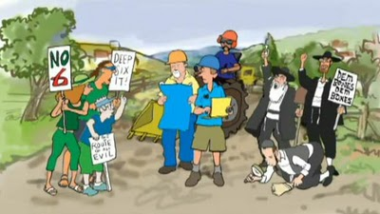

PRODUCT FORMAT: A series of weekly two-and-a-half minute illustrated and animated news segments – each devoted to one topic or news item gleaned from the Hebrew press, designed to balance conflict-driven news coverage with one upbeat and offbeat snippet of zany news.

PRODUCTIONS TEAM: Daniella Ashkenazy – producer and scriptwriter Avi Katz – illustrator Victoria Feinerman – voice talent Eli Ben-Zeev – video and sound director

SLIDE #23:
CHELM-ON-THE-MED© ANIMATED NEWS SEGMENTS FOR TELEVISION (ADVOCACY VALUE)

BROADCASTING FORMATS
► Closing item or follow-up to televised news from or about Israel
► Stand-alone ‘corner’, 'special' feature on talk shows, etc.
► Ad-hoc usage

BROADCASTING PLATFORMS – SUITABLE FOR:
1. Weekly Broadcasting (Affiliate Stations)
■ American Jewish ('Ethic') Channels
■ Foreign Jewish Channels (with subtitles/dubbing in Russian, French, etc.)
■ Pro-Israel Christian Channels (Gospel TV – Europe; CBN (i.e. Pat Robertson – USA)

2, Ad-Hoc Broadcasting
■ Odd News Beats on commercial news networks/talk shows
■ Online Jewish newspapers with video/ Odd news sites
■ Online mainstream newspapers with odd news video/Best on the Web corners
■ Animation and technology websites

- Other Distribution Channels bundled on DVD.

DVD is suitable for: JCCs, religious social frameworks (synagogues and churches), Jewish schools/summer camps/youth movements; advocacy gatherings and campus viewings; Jewish humor festivals, Purim/Israel Independence Day celebrations, Hillel houses and Israel Houses programs, home entertainment.
SLIDE # 24:
"ANIMATED NEWS" IN GLOBAL PERSPECTIVE

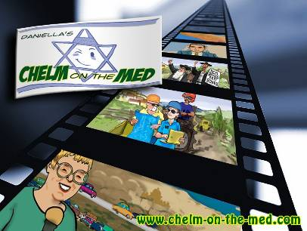

ANIMATED NEWS
- a breakthrough concept
- a hot media issue

WHO IS PRODUCING ANIMATED NEWS?
- a David
- and a Goliath…

Only two entities have raised the Animated News banner.
They are very different. So are their products.


● NEXT MEDIA - TAIWAN: A Taiwan-based media conglomerate founded by media mogul billionaire Jimmy Lai. \


● CHELM-ON-THE-MED© PRODUCTIONS – ISRAEL: An Israel-based upstart startup, with zero capital.

SLIDE # 25: "ANIMATED NEWS" IN GLOBAL PERSPECTIVE (CONT.)

ANIMATED NEWS IS HOT NEWS!
Next Media's animated news is a 'hot and highly-charged' issue, that has been profiled (and derided) in major features – including ● The Wall Street Journal ●The New York Times ● The London Guardian ● CNN ● TIME

VIEW NEXT MEDIA ANIMATED NEWS SEGMENTS:
☼ Opening segment (Nov 2009) of Tiger Woods: http://www.youtube.com/watch?v=7i5FlC1MpkE

☼ JetBlue cabin attendant's dramatic "I quit" exit: http://www.youtube.com/watch?v=QBvakgglAPM

☼ The Hong Kong tourist bus massacre in the Philippines (Sept 2010): http://micgadget.com/7806/philippines-hostage-crisis/
SLIDE #26:

CHELM – AN ANIMATED NEWS MODEL FOR OTHERS

Howard Kurtz of the Washington Post said in December 2009 on CNN's Reliable Sources when the first Next Media segment (of Tiger Woods) was released that the animation was "…very entertaining but it was nothing approaching journalism. It didn't look like journalism. It didn't smell like journalism, it didn't feel like journalism. So let's not confuse a bunch of cartoons with what people in the news business do."

Daniella Ashkenazy: "We live in a technology-driven world. Animated news isn't going to go away. Lock the door – it will come in the windows. The only question is: What kind of usage use will enhance news, what kind will be detrimental / irrelevant?

SLIDE #27:
CHELM-ON-THE-MED© PRODUCTIONS'
GUIDELINES FOR USAGE OF 'ANIMATED NEWS'

♣ BEAT PARAMETERS: – Animation is suitable for SOFT news, not HARD news

♣ ARTISTIC LICENSE: Artistic license should not go beyond the facts to 'imagined' happenings.

♣ PRESENTATION AND SCOPE: Animation needs to avoid blurring the lines between real footage and re-enacted footage – refrain from dove-tailing animated news segments with genuine videoed footage. Occasional animated re-enactments that contribute to regular news coverage (how two planes ended up on the same runway, stages in the Marmara encounter, economic processes) should avoid confusion by use computer game figures or cartoons, not life-like contrived figures.

♣ WEIGHT: If used along side HARD news, animated SOFT news should follow the serious side of the news (no 'salads') and should be limited to one item or a short medley of items. There is no such limitation on the number or length of items that can be bundled together in programs devoted to piquant news or comedy.

♣ USAGE: Under the above guidelines, the CHELM paradigm for animated news is not limited to Israel and can serve as a model for other news-gatherers using animation.

SLIDE 28:
STRATEGIC PARTNERS NEEDED

► THE 'CHELM PROJECT' is looking for a PUBLIC FIGURE to serve as honorary president (the 'public face ') of The Chelm Project – lead the project with appearances in the media and contact with potential backers.

► CHELM-ON-THE-MED© PRODUCTIONS is looking for a SPONSOR/PHILANTHROPIST or a CONSORTIUM OF SUPPORTERS to underwrite productions costs for a full year (52 segments): $400,000 (est.)

SLIDE 28:
COST-EFFECTIVENESS

CHELM animated news segments can reach a mass audience, including publics currently beyond the reach of traditional advocacy, at a relatively-low-cost.

COMPARE:
► NEXT MEDIA invested $30 M and 2½ years of R&D developing an expensive, inferior and inappropriate product with a staff of 180 at a zillion dollar state-of-the-art studio. CHELM built its model in 6 months (on-and-off) developing a superior product – done entirely on-spec by a team of four on standard PCs (in four locations).

► CHELM segments will run $7,700 per segment (including production, transmission, advertising) –aired weekly for a full year. LATMA's spoofs "We Con the World" and "The Three Terrors" costed $15,000 each to produce, are sporadic and reactive rather than ongoing and proactive.

► Model Gal Gadot's photographs in MAXIM – exposure orchestrated by the NY Israeli consulate – reached 1.5 million subscribers to the men's magazine. The first AFFILIATE CHANNELS to come on board – Jewish Living TV and the Jewish Television Network – each reach 30-40 million households.

THE ISRAELI PROTOTYPE for animated news can not only improve Israel's image in the world. For those who lend their names and support to this endeavor, The Chelm Project – pioneering and professionally ahead-of-the-pack – can be a source of pride and prestige – as people of leadership and vision

► Chelm's OPERATIING PRINCIPLES are the first SERIOUS use of animated news segments and can TRULY challenge traditional means of presenting news on television, without losing quality.

► Chelm's PRODUCT PROTOTYPE is applicable to odd news and other soft news content everywhere. Low-cost. High-Quality. Effective. Relevant.

Let's change Israel's image – one chuckle at a time!*

* a phrase "borrowed" and paraphrased from a lecture ("Drawing upon Humor for Change") by cartoonist Liza Donnelly on TED, about how humor can empower women to change the rules.
SLIDE #29:
Questions? Comments? Ideas? Want to Help?

CONTACT DANIELLA ASHKENAZY

► TELEPHONE: 972-8-8585672

► SKYPE: d_ashkenazy

► E-MAIL: ashkenaz@zahav.net.il

► VIA THE WEBSITE FEEDBACK www.chelm-on-the-med.com



THE END
(appendixes follow)


APPENDIX A
OTHER USES OF HUMOR BY HASBARA ENTITIES

THE POWER OF HUMOR:
COMPARE AND FIND THE DIFFERENCES

I. WRITTEN HUMOR IN THE ISRAEL CONTEXT

SAMPLE #1: INFORMATION & DIASPORA MINISTRY’S MASBIRIM CAMPAIGN: Passage from a booklet of ‘common myths and suitable responses’ published by the (e.g. Humor is limited to the come-on for Israelis going abroad to enter the website (www.masbirim.gov.il in order to learn how they can be ‘traveling goodwill ambassadors’.)

MYTHS: “Israel has a dictatorial regime imposed by the Army.”
Not true. Israel is considered one of the most stable democracy’s in the western world, and certainly in the Middle East. Despite the wars we have experienced and ongoing terrorism campaigns, most of the state’s inhabitants live in protected areas, distanced and isolated from areas where military activities take place. The Israeli army operates according to humanitarian morals, and for good reason it is called the “Israel Defense Forces” because its role is defense and never attack. Moreover in contrast with dictatorial countries, in Israel there is a totally free press. This is substantiated by our Internet usage, which is considered among the highest in the world.

SAMPLE #2: BLUESTARPR.COM ANti-ISrael Fixation Syndrome Poster rolled out to combat Aparthid Week in April 2010 ‘alludes’ that demonizers are assholes*...

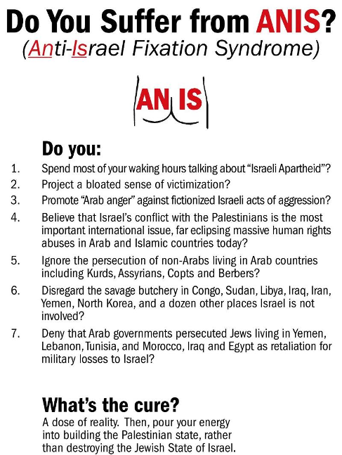

* ANIS (sic.) - not anus

II. USE OF VIDEO CLIPS IN THE ISRAEL CONTEXT

SAMPLE #1: ISRAELATHEART.COM
The video clip by the Israel at Heart NGO shows a sexy sabra slowly walking along the Tel Aviv beach, turning her head to flirt back at Israeli guys who are shamelessly ogling the head-turner …as she unsuspectingly walks straight into a wooden pylon…climaxing with the message: “Israel can be a dangerous place”.
http://www.israelatheart.org/video.php?file=newspics/mtv.wmv

SAMPLE 2: CANADIAN FEDERATION OF JEWISH STUDENTS' controversial "Size Doesn't Matter" clip prepared to deflate Boycott Israel on Campus Week, with a young couple seemingly chatting about oral sex and the small size of the guy’s equipment that turns out to be a discussion focusing on a travel map of Israel in the fellow's lap and whether Israel is too small to rate as a place to tour.
http://torontoist.com/2010/02/selling_israel_with_sex_bad_taste_or_good_marketing.php

SAMPLE 3: RECENT USE OF CONFLICT-DRIVEN SATIRE VIDEO CLIPS

● LATMA ('SLAP') A parody in response to media bias following the Turkish flotilla to Gaza in June 2010 produced by Caroline Glick and associates – "We Con the World" (a parody of "We are the World, We are the Children") received one million hits on You-Tube. http://www.israellycool.com/2010/06/04/we-con-the-world/
The second parody – The Three Terrors (a parody of The Three Tenors) was also successful. http://www.youtube.com/watch?v=VmffgIqlAYA&feature=player_embedded

● NO LAUGHING MATTER Mock media interviews done in dry English humor – including the UN Secretary General, a Hamas leader and Iran spokesperson.
http://www.nolaughingmatter.tv

● DANCING SOLDIERS IN HEBRON A parting shot to their military service, filmed by a group of Nachal soldiers showing the soldiers in full battle dress on patrol dancing to Tik Tok by Kesha. Uploaded to YouTube it was an instant attraction. http://www.youtube.com/watch?v=xVVte550dyU

APPENDIX C: DRAFTS FOR CHELM POSTCARDS FOR DISSEMINATION ON COLLEGE CAMPUSES (A TACTIC USED BY BLUESTARPR.COM WITH SERIOUS MESSAGES)

SAMPLE 1:

PICTURE SIDE | MESSAGE SIDE
ISRAEL DOESN’T HAVE  ‘TWO JEWS – THREE OPINIONS’  That would be too manageable.  Illustration  by Avi Katz  The Jewish State is ‘blessed’ with… | A ROLLICKING DEMOCRACY with  ► 86 registered parties – 9 of them Arab parties and 5 ‘green’ parties.  ► 33 ran in 2009 elections  ► One wanted to legalize grass, another casinos; and a third would allow citizens to sue the banks. Five were Arab parties.  THE KNESSET has 12 factions – 3 of them Arab parties. The House is annually  ► seasoned by 3,500 Parliamentary Question to the Government;  ► peppered by 2,500 Private Member’s Bills – not counting those sponsored by the Coalition, the Opposition and specific parties or caucuses.  THE COALITION GOVERNMENT is a boisterous affair:  ► a 5-party coalition – embracing 57.5 percent of Parliament;  ► The Cabinet is now seeking stenographers since transcribers can’t keep track of ‘who said what’ with…30 ministers in the Government.  HOW COULD A THIRD (!) OF THE GERMANS, SPANISH AND ENGLISH AND TWENTY PERCENT (!) OF AMERICANS RECENTLY POLLED POSSIBLY THINK ISRAEL IS HEADED BY A DICTATOR ???

SAMPLE 2

PICTURE SIDE | MESSAGE SIDE
SOLDIER, ARE YOU DEAF?  Illustration  by Avi Katz  AS A MATER OF FACT – YES! | Where can you find a high school jock, a recent kidney donor, a promising mezzo-soprano, a fashion model, a math genius, a delinquent high school dropout, a Muslim Bedouin shepherd and a Jewish Talmudic student with side curls down to his shoulders, all in the same room?  The IDF Induction Center.  Meet Israel’s Not-One-Size-Fits-All Army.  It’s not a manpower issue at all. It’s all about not marginalizing people with special needs to serve. And they serve their society as draftees and volunteers in a host of capacities tailored to their abilities and disabilities – including remedial reading teachers for the dropout. And the organ donor?  Oh, he was posted as an ORGANizer, urging others to sign organ donor cards.

SAMPLE 3

PICTURE SIDE | MESSAGE SIDE
IN ISRAEL  ANYONE CAN GET THEIR DAY IN COURT. NOT JUST ANY COURT…  Illustration  by Avi Katz  IN ISRAEL'S 'ANYTHING GOES'  SUPREME COURT! | Israel’s Supreme Court fields direct appeals from persons who think a government body has overstepped its authority or failed to act reasonably and with proportionality.  Petitioners submitting High Court of Justice (BAGATZ) Appeals don’t even have to be Israeli citizens. There have been countless appeals brought by Palestinians challenging Government or IDF policy. But that’s not all.  A petitioner need only show "reasonable likelihood of prejudice to a legal right" for standing. And the Court’s outlook is that almost “everything is judicable" –ranging from a citizen's right to be "eaten by wild animals after he was dead" claiming this was "only repaying a debt to nature as a lifetime consumer in the food chain," to a belly dancer sacked after overzealous food supervisors declared her performance inappropriate for a kosher wedding hall. The Bench sternly ordered the men to keep their minds on the kitchen, and their eyes on the tables – not on the floor.
APPENDIX C: ARE ISRAELI ODD NEWS STORIES NEWSWORTHY?
YOU BE THE JUDGE.

A TYPICAL SELECTION  OF ODD NEWS WORLDWIDE | A TYPICAL SELECTION  OF ODD NEWS FROM ISRAEL
A woman has her husband's ashes made into an egg timer when he dies so he could still "help" in the kitchen. | A man petitions the supreme court claiming the right to be eaten by wild animals when he’s dead to repay nature as a lifetime consumer in the food chain  .
A shipping clerk packs himself in a crate and air-expresses himself home at company expense. | An avid theatre-lover is caught in the act, paying for tickets to The Miser with a forged credit card.
Rayanair Airlines takes no-frills cut-rate tickets a step further with plans to charge customers to use the toilets on short flights. | El-Al offers dirt-cheap dead-of-winter weekend flights to Europe without telling Israelis where they’ll be landing in, until minutes before departure.
Two robbers are in the middle of a heist when one changes his mind and arrests his partner-in-crime. | A security guard decides to hold up the very bank he was hired to protect against suicide bombers.
No breathalyzer needed when a tipsy motorist is sighted trying to perform mouth-to-mouth resuscitation on a run-over opossum. | A police breathalyzer being independently tested for accuracy identifies orange juice as alcohol. *
A mother sneaks in and out of boot camp to accompany her son on guard duty because he’s afraid of the dark.

City elders in Hadera agree to build a replica of the Eiffel tower in the town center to ease the adjustment of Parisian immigrants.

Used mikvah water is channeled to irrigate municipal parks in water-short Israel.

A divorce court rules a divorcee will pay his ex a pregnant goat a year for the next 35 years, raising questions ‘who got whose goat’.

A new branch of IKEA, offers hungry shoppers falafel, not just hotdogs and Swedish meatballs.

APPENDIX D:
WHAT ARE OTHERS SAYING ABOUT CHELM?
(A SAMPLING)

OFFICIALDOM:

Creative and Refreshing
Amir R. Gissin, Consul General of Israel, Toronto: "The concept of using humour to break down stereotypes and preconceptions about Israel, and doing this by sharing offbeat amusing stories published in the Hebrew press, is certainly creative and deserves our support. I found the site well crafted – funny and endearing, and it is a truly refreshing 'take' on Israel. We need more of this kind of light-hearted input in our advocacy efforts."
PROFESSIONAL OBSERVERS:

A Perfect Counterbalance

Mike Burstyn, Israeli Off-Broadway actor-performer: “Chelm-on- the-Med helps me keep up with the humorous, unique and positive aspects of our modern Israeli society. It is a perfect counterbalance to the negative and false images of Israel available via the worldwide Media.”
Clever and Upbeat
Mark Schiff, comedian: "...Chelm-on-the-Med is clever and upbeat. These quirky news stories (some truly unbelievable) are not just funny. They cast Israel in an entirely new light. Chelm-on the-Med makes my day more interesting but also more fun."
Epitomizes Life in Israel
Prof. Sam Lehman-Wilzig, political scientist/media scholar: "Chelm-on-the-Med's news stories are the very essence of what living in Israel is like: lots of creativity, rule-bending, circumlocution, and eccentricity in a nation full of off-beat citizens. There is no better way to show Israel's 'normality' than to highlight its abnormalities."

RUN-OF-THE-MILL READERS:

ENGAGING STYLE:
♣ “dazzling alliteration” ♣ “crunchy idiosyncratic style” ♣ “… reminds me of This is True” ♣ “like the New Yorker’s hilarious and literate fillers, gone but not forgotten” ♣ “Daumier-style political caricature so missing in the modern day press”

THERAPEUTIC POWER OF A GOOD CHUCKLE:
♣ “I just found your site, and am rolling in the aisles. It should be publicized more widely in the U.S.”
♣ ‘Today, I really needed a good laugh... and I found your stories.(I am a firm believer in Benevolent Fairies!) I clicked my way through your Archive and can't wipe the grin off my face! I want to tell you how much you have brightened my evening.”
♣ (from Uruguay) “…delighted to discover your column as a source of good mood and inspiration…we need sources of inspiration, proudness and chutzpah to build meaningfull Jewish life.”

‘ISRAELIS ARE HUMAN’:
♣ “…a great counter-balance to the demonization of Israelis…Your columns show that Israelis (as if we didn't know) are human like everybody else.”
♣ A South America wrote: “What a wonderful idea! I am sure you could create another website with similar bits from Argentina, where I live!!”
♣ A New Yorker wrote: “…looks like wacky-time is not limited to NYC.”

ONE-OF-A-KIND WEBSITE:
“As a dyslexic that is hopeless at Hebrew, I have to rely on my husband to translate snippets of Israeli news that just don't show up in the English press…I know that there is more to Israel that I am missing out on. Your Web site helps fill in that gap for me. Thanks!”

See: http://edition.cnn.com/2004/US/12/17/yir.offbeat/ First place is a bear that passed out after consuming three dozen cans of beer at a campsite, another highlighted Canada actively seeking to attract Americans émigrés to Canada among those disappointed with the results of the 2004 Presidential election.

